Udemy java- sjoglekar gmail account
Java from zero to first job
JVM and garbage collector take care of memory mgmt.
Mobile, desktop, web applications using java
Compile your src code to java bytecode, bytecode is executed on JVM
JVM is specific to OS.
JRE= JVM+ java binaries and classes needed to execute the program
JDK= JVM + JRE+ tools for java development
Debugger is in JDK
Java LTS(long term support)- version of java that will remain the industry standard for years
Open JDK is free for commercial use. Oracle JDK is not free for commercial use.
Jdk- downloaded in a folder, but from other folder if cmd is opened, java won’t be recognized.
That’s why we add in environment variable.
Console application- works with data input and output on command line.
.java file after compilation-> .class file (byte code) , JVM executes .class file

Creating java file from cmd prompt->
Open cmd from particular folder. Type- notepad Helloworld.java and press Enter.
The name of public class should be the same as that of java file
After writing the code, write- javac filename.java on cmd and press enter.
filename.class file will be seen in the folder
To run the .class file on JVM-> write java filename on cmd and press enter. (.java extension is not needed at this step)

IDE= code editor, build automation tools, debugger, compiler
Eclipse-> Window-> Show view
Module- mechanism to package java application and java packages, we can make particular packages visible

Eclipse shortcuts
Ctrl+D – delete a line
Ctrl+ space- list of suggestions pop up while typing
Ctrl+F11- run the program
Type sysout and Ctrl+space -> System.out.println()

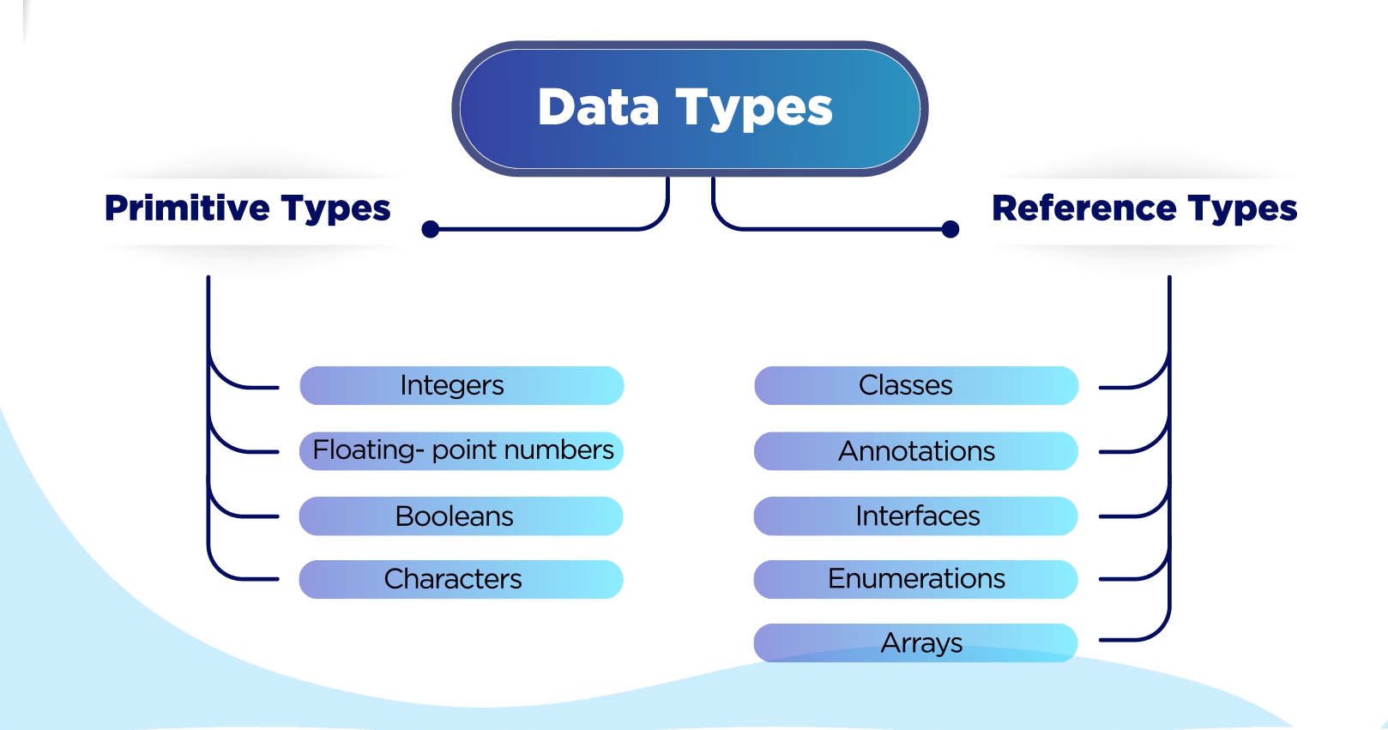

Primitive data types store actual values. Reference types store address.
Size of boolean is virtual machine dependent.
//long l2= 2_000_00_000_00; Out of Range error
long l2= 2_000_00_000_00L; // write L at the end to tell the compiler that it's long

//char c1= 700000; // this is out of range 0 to 65535
char c2= 95; // character with number 95 in unicode will be assigned to c2

byte y2= (byte)129;
System.out.println(y2); // -127

Debugging in eclipse- I DID NOT UNDERSTAND
Double click on the line and set breakpoint
Right click- debug as java application
Select any expression in eclipse- right click and select watch
You can add more expressions
Select and right click- display
Debug shell- change the value of variable during debug

Package presentation
In right corner of Project explorer, option of Package presentation-Flat, Hierarchical

--Package inside package
--While creating the class, writing new package name- creates new package and class goes inside it.

Refactoring the code-
Select the text and press Alt+Shift+R. Now what you type will be reflected everywhere that text was present. This is used for variable name

Ctrl+Shift+F – code formatting(text alignment, spacing, brackets one below other etc.), either select the text and format it OR directly press the keys

Alt+Shift+L – to substitute all occurrences of expression. This is used for expressions other than variables. Select 10+5 and all occurrences of 10+5 will be replaced by the text you provide.

Alt+Shift+M – select the required text, press Alt+Shift+M and the text will be put inside a function.

Ctrl+Shift+O – necessary classes from the packages will be imported.

int bin = 0b10011000; // '0b' prefix --> binary literal
int oct = 0230; // '0' prefix --> octal literal
int hex = 0x98; // '0x' prefix --> hexadecimal literal

